Introduction
The Arizona Healthcare Workforce Development Coalition (AHWFDC) includes members from AHCCCS, Arizona Complete Health, Banner University Family Care, Care 1st, Department of Child Safety Comprehensive Health Plan (DCS CHP), Department of Economic Security/Division of Developmental Disabilities (DES/DDD), Health Choice Arizona, Mercy Care, Molina Complete Care and UnitedHealthcare Community Plan. This group represents ACC, ALTCS, DCS CHP, DES/DDD and RBHA Health Plans. Together we ensure that initiatives across the state of Arizona align with all lines of business.
According to the 2021 State of Workforce Management Survey Report “You can’t improve what you can’t measure, which is why metrics are the key to success . . . Metrics, and specifically real-time reporting capabilities, provide essential insights into the effectiveness of workforce management strategies.”
It is the responsibility of each Contractor to gather data metrics that are outlined in ACOM 407 Attachment A. In response to this policy requirement, the Coalition pioneered a collaborative effort to create a method for gathering data across all Managed Care Organizations (MCO’s) and all lines of business in the state of Arizona. From this collaboration, the Coalition built the ACOM 407 Attachment A Provider Survey. The name has been changed to AZ Healthcare Workforce Goals and Metrics Assessment to align with regulatory policies and initiatives.

Executive Summary
Arizona’s Network response to Workforce Development has been working towards a more uniform and collaborative approach that will allow the forecasting of the workforce needs based on solid statewide data. In an effort to be more proactive and strategic, the Coalition created the ACOM 407 Attachment A Provider Survey to gather baseline data. The JotForm platform was purchased to create the survey for dissemination.

Survey Goals
- The survey was created to gather baseline data for Arizona’s Network of Providers in the areas of recruitment, turnover, and retention.
  - This was accomplished through a single Provider survey disseminated from one source.
- The Coalition works collaboratively to utilize the data collected, to inform Arizona’s Network of Providers and establish strategies for improvement. Some of these interventions may include:
  - Implementing strategies in recruitment, turnover, and retention efforts
  - Recommending actions to change recruitment, selection, training, deployment, and/or retention practices for critical workforce gaps in the statewide collaborative workforce development plan
  - Assessing Provider capacity and the ability to respond to Member needs
  - Maintaining a Provider Network of sufficient and qualified workers
  - Understanding the existing strengths within the current Network and how to sustain those strengths

Key Findings
In total, the Coalition received submissions from 377 Provider agencies representing all counties, while we appreciate these responses they are limited in comparison in the overall size of the network. This contributes to the limited ability of the Coalition to make strong recommendations. The submission size was only 10% of the overall possible responses. It is imperative that in subsequent years the AZ Healthcare Workforce Goals and Metrics Assessment responses increase significantly to address the workforce needs.
The data was collected via JotForm, was compiled in Excel, reviewed, and analyzed. Unfortunately, JotForm had several limitations for extracting the data which impacted the Coalitions ability to filter and complete cross analysis with the data set.
The following sections highlight key findings from several data sets relevant to Workforce Development for all lines of business. These findings will inform recommendations to improve WFD data collection moving forward in 2022 and approaches for improving the statewide workforce.

Provider Agency Representation by County
In this section Providers were asked, “What counties does your agency provide services in?”
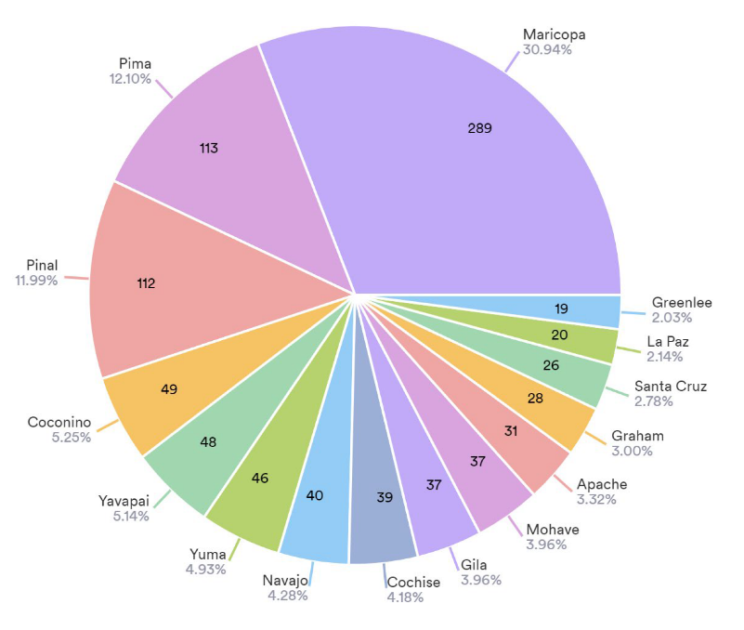

Workforce Median Age
In this section Providers were asked to input the median age of their workforce.
  - The data shows there is an opportunity to recruit from the 18-24 and 55-64 age bracket.
  - It is important to note there are 4 % of the workforce represented in the 55–64-year-old range.
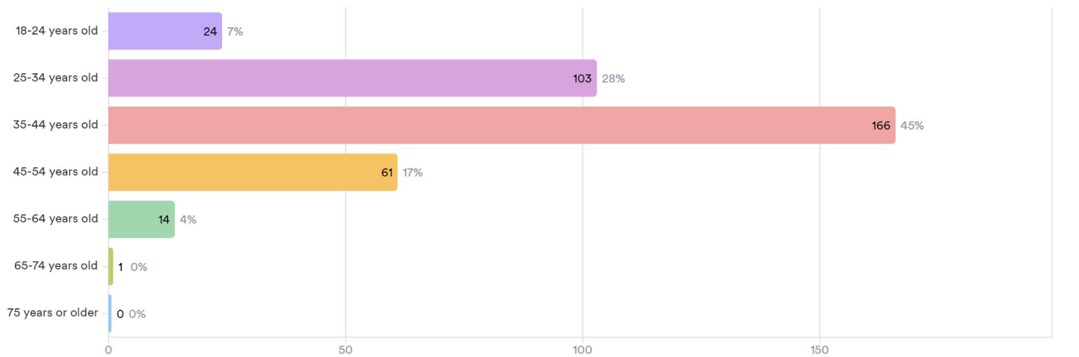

Onboarding Time
In these sections Providers reported on the average time spent onboarding new hires for licensed and unlicensed positions.
- There is not a significant difference in onboarding time of licensed vs. unlicensed staff
Licensed Unlicensed
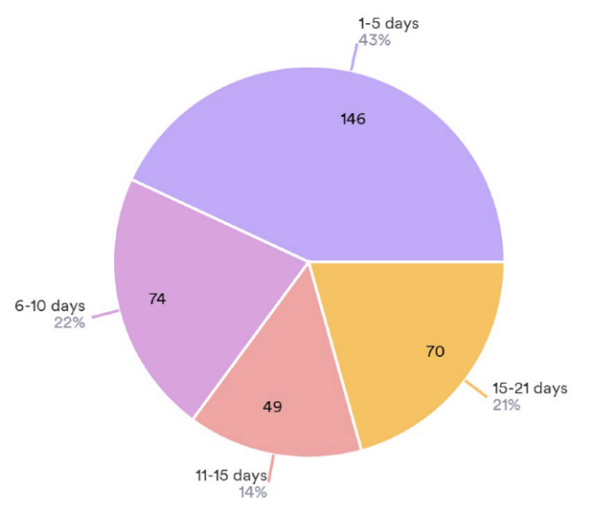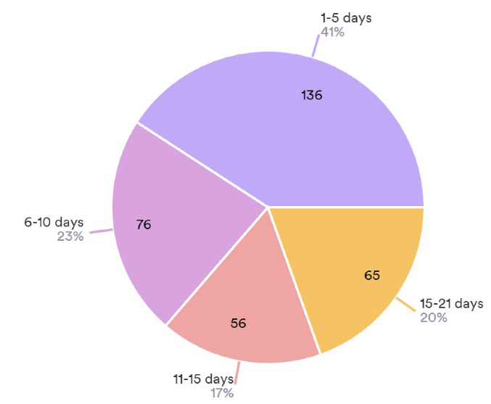

Difficult to Fill Position
In this section, the survey responses aligned with what we are hearing from Providers directly. This question allowed for multiple selection shown by the higher number of responses vs. the number of Providers who completed the survey.
- Direct Caregivers/Direct Care Workers remain the most difficult position to fill.
- BH Direct Care Professional/Direct Care Workers were also difficult to fill according to Providers.
- Other Entries: This category included a wide variety of unique responses (38) including: Data Analyst, Licensed CNA, Front line supervisor/manager, BCBA, food services, bilingual support, etc. The largest number of “other” was less than .009% of responses. The plan for the 2022 Assessment is to create a larger variety of categories to capture more accurate data.
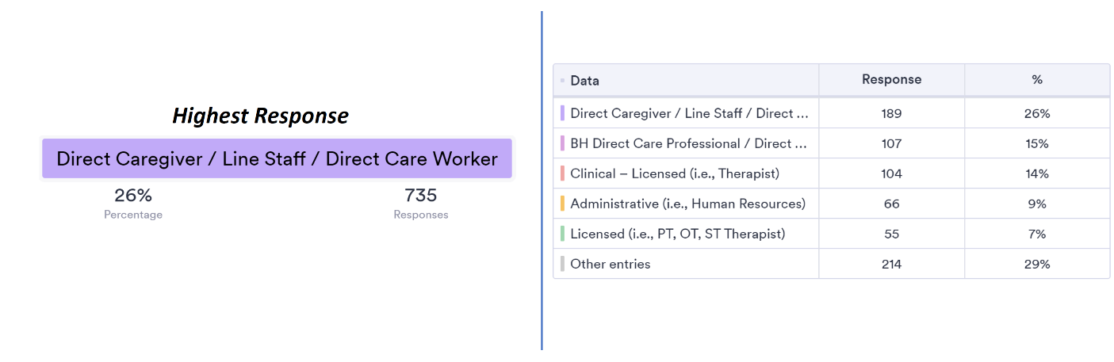

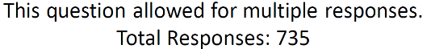

Workforce Gaps
In this section Providers were asked what the critical gaps in their workforce were. This question allowed for multiple selection shown by the higher number of responses vs. the number of Providers who completed the survey.
- Recruitment scored the highest at 42%, and retention second at 27%
  - Ideas to support recruitment include scaling the Employment and Resource Fair that the ALTCS WFDA is implementing in Q1 of 2022.
  - The Coalition will explore making supervisory and leadership training best practices available to Providers.
  - AHCCCS plans to include a statewide Caregiver Campaign for awareness in ARPA.
  - The Coalition will continue to focus on what recruitment and retention needs are specifically and continue that dialogue with the AZ Council of Human Service Providers that collects retention metrics.
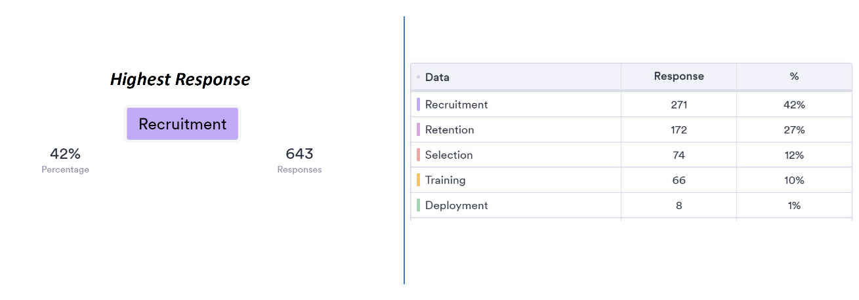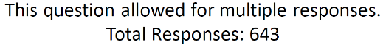

Average Length of Employment
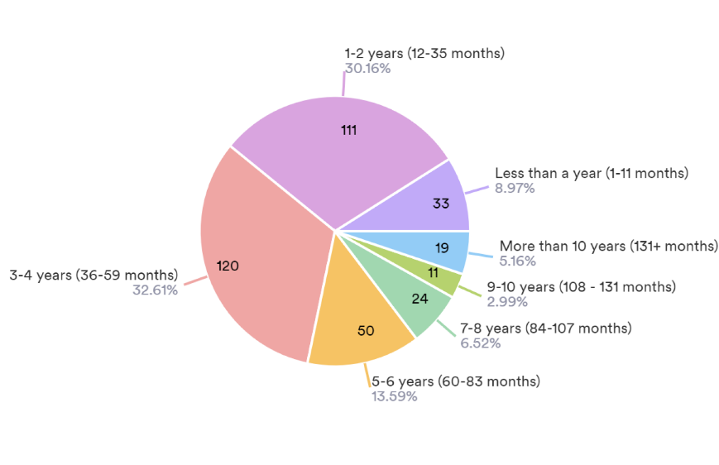
In this section Providers were asked to input the average length of employment at their agency.

- Based upon the survey data, nearly 40% of the workforce have an average length of employment of under 2 years.

-In the next version of this assessment, the Coalition will highlight relationships between the average length of employment and different positions

Retention and Turnover Metrics
Retention and turnover were calculated using the following formulas
- Retention: Retention = # of FTE's on 9/1/20 divided by # of FTE's on 08/31/21. Multiply the answer by 100 to get the percentage. Please note, any recent acquisitions were excluded.

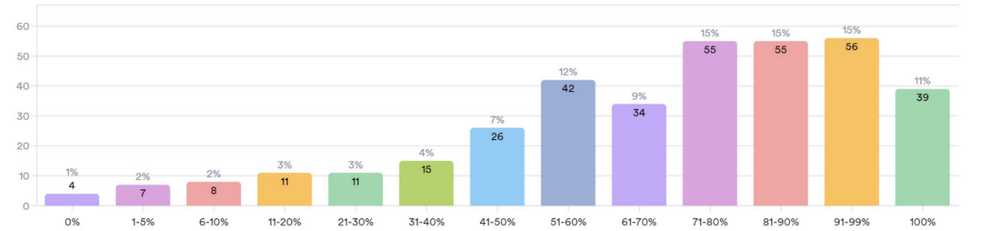
Retention Rate
Number of Providers

- Turnover: Turnover = #FTE ON 9/1/20 + #FTE ON 8/31/21 divided by 2 = AVERAGE #FTE DURING PERIOD (X) #FTE SEPARATED DURING PERIOD (9/1/20-8/31/21) /divided by AVERAGE #FTE DURING PERIOD (X). Please note, any recent acquisitions were excluded.

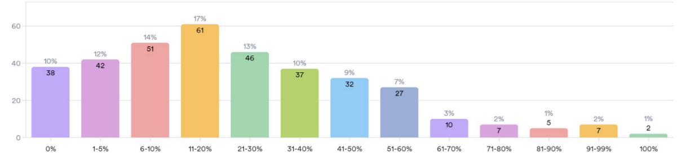
Retention Rate

Generally, a retention rate of 90% or higher and a turnover rate of 10% or lower is considered above average.
- 64% of agencies within the Network are reporting retention rates of 61% and above citing reasons such as positive environment, culture of respect, support from supervisor, support form upper management, communication, and feedback.
  - The Coalition will further investigate into how these high performer’s workforce initiatives may work in other geographic areas and across the network.
- 91% of agencies in the Network are reporting turnover rates lower than 60%, citing reasons such as employee compensation, work-life balance, employee benefits program, lack of support from supervisors and upper management.
  - In the next version of the assessment the team will look for correlations pertaining to this such as region, organization size, types of services provided etc.

Conclusions
In the 2021 ACOM 407 Attachment A Survey, 377 Providers submitted responses, which is less than 10% of potential number of responses. In order to impact change and make concrete recommendations that are representative of the Provider Network as a whole, we need a significant increase in Provider participation in the 2022 AZ Healthcare Workforce Goals and Metrics Assessment. This will be a large undertaking that will require support from the Provider Network and all Health Plans to achieve our goal. Understanding the existing strengths within the current Network and how to sustain those strengths will be a focus of the Coalition
In this first attempt to gather baseline data the Coalition learned there were several limitations in the JotForm data analysis that did not allow filtering, cross analysis, and comparison of data sets. The team is currently researching additional platforms to perform the functions needed to gather more specific data. The Coalition will continue to refine the process; establishing baselines and providing further data analysis to inform and direct workplans and goals for implementation of the AZ Healthcare Workforce Goals and Metrics Assessment (note name change).

